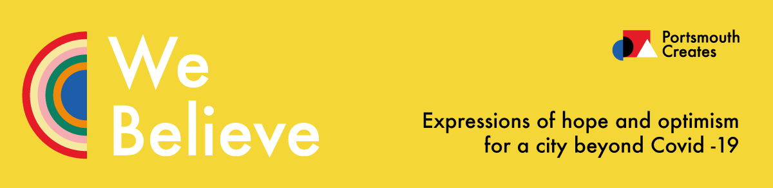

Application for ‘We Believe’ micro-commission

(Please read the entry criteria and Terms & Conditions before completing this application)

Portsmouth is a vibrant cultural mosaic. A hotspot for art, not limited to galleries and opera but inclusive of everything from music to art, dance and design, events, writing, film making, digital media, theatre & museums…
Portsmouth Creates CIC is a newly established Community Interest company set up in 2019 to be an
independent voice to connect, enable and champion culture, across the city of Portsmouth. We
have big ambitions to be a major catalyst for cultural investment and activity in the city and
make it a better place for people to live, work, play and visit. Our aim is to harness the vast array of talent that exists within the city and provide access to collaborative opportunities and creative engagement for everyone, regardless of background.
During the Covid-19 pandemic many people within our creative sector have fallen through the cracks, unable to obtain any financial support due to the nature of their work, with a hugely detrimental effect on their business and personal lives.
Our ‘We Believe’ project aims to support our awesome creative community by providing some small financial relief for 20 local artists via micro-commissions in the form of artwork to be exhibited across the city’s A1 poster sites, alongside Damien Hirst’s Rainbow artwork and in association with Portsmouth City Council’s Crowdfunding scheme. It will also be used to create a citywide arts trail whereby the public can download a link to artists information and inspiration and will provide a great opportunity for artist promotion. Selected artists will be paid £500 per micro-commission.
The artwork theme is:
‘We Believe- Expressions of hope and optimism for our city beyond Covid-19’ and can be interpreted however the artist chooses, using a medium of the artists choice, with a view to sending out an inspiring and uplifting message to the people of Portsmouth during these difficult times and spreading positivity. A signed copy of each of the artworks will be catalogued in the City of Portsmouth's Covid-19 collection held by the Museums and Records Service to serve as a historical reminder of Portsmouth’s inspirational sense of community and resilience during these times.
The selected artists will incur no financial costs and Portsmouth City Council have kindly agreed to meet the print and installation costs.
We are very excited by this project and cannot wait to see more original and uplifting artwork across our city.

To apply for this project artists should:
- Live and work in the Portsmouth area PO1-PO6
- Not have received funded support through either the Government Small Business Grant or Leisure & Hospitality scheme and should rely upon their artistic output for a significant element of their annual income
- Be able to submit a completed piece of artwork within 2 weeks of notification of selection
- Submit work that has not been used in previous Portsmouth Creates projects
- Be able to submit or transfer (dependent upon art media method) their finished work digitally for print reproduction at A1 size (minimum 300 dpi resolution) in order to display across city poster sites.

Personal Details
Your name:
Artist name if different from above:
Address:
Landline:
Mobile:
Email:

Have you got a website / social media? If yes please provide the links.

We want the artwork to be artist led around the theme of ‘We Believe – Expressions of hope and optimism for our city beyond Covid-19.’ It is not necessary to submit ideas,
however, if you have a specific project idea in mind please feel free to provide a
short description of your idea.

Please enclose/attach up to 5 images of previous artwork completed within the last 2 years:

Have you received support through either the Governments Small Business Grant scheme or Leisure, Retail and Hospitality scheme?

Please state whether you have read the terms and conditions
Yes/No

Signed:

Dated:

Print Name:

Please send your application form and supporting documents via email to info@portsmouthcreates.co.uk by 22nd June 2020.

